

My Target: ____ / 46 (Notes) or ______ %

🖒 🖓 (Circle when your work is handed back)

**Name: __ ____________ Teacher: ______**

Yr 9 Humanities & Social Sciences:  *The Making of the Modern World*

***Task Five: In-class Assessment***

***“A Soldier’s Story”***

***Historical Inquiry Task***

**Part 1:**Your teacher will provide an article about a WWI soldier. You must read the article and then take notes from the article to assist with questions. This is to help you understand what an article looks like and how it could be used as a source to gather information.

**Rules for taking notes:**

**What to take: What to leave:**

* Main ideas only Functional words – like, the, as etc
* Key words Opinions and decorating expression
* Use generic terms Examples
* Use abbreviation and signs
* Use organisation to create an order

**Part 2:** Now you must choose your own soldier from WWI. This can be a relative if you wish. Take notes about your soldier as you did for Part 1 based on the 10 questions provided.Use various sources, including articles to gather notes. Include a bibliography.

***You will find these websites useful:***

1. National ANZAC Centre

http://www.nationalanzaccentre.com.au/story/

1. National Archives of Australia

<http://discoveringanzacs.naa.gov.au/learn/>

1. Australian War Memorial

<https://www.awm.gov.au/>

**Part 3: In-class Historical Inquiry Task Assessment (6%)**

In class communicate your findings from **Part 2** of the investigation. Use the information from the soldier you have chosen and researched to address questions. The questions will be based on the 10 questions used in both Part 1 and Part 2. You will not be addressing all of the questions. You will be addressing a selection of these questions, which will be constructed using *‘action words’* or *‘key directional words’.*

**Rules for writing a newspaper article:**

**Did the first article follow the rules?**

1. **Compile all your facts.** Before you write a news article, make a list or outline of all the pertinent facts and information that need to be included in the article. This fact list will help prevent you from leaving out any relevant information about the topic or story and will also help you write a clean, succinct article. **You will get this information from your notes.**

**2. Start with your lead.** News articles begin with a leading sentence that is meant to grab a reader's attention and interest them. This is one of the most important parts of the piece, so start with the leading statement when writing a news article. Your lead should be one sentence and should simply, but completely, state the topic of the article

1. **Give all the important details.** The next important step to writing News articles are including all the relevant facts and details that relate to your lead statement. Include the basics of what happened, where and when it took place, who is involved and why it's newsworthy. These details are important, because they are the focal point of the article that fully informs the reader.
2. **Follow up main facts with additional information.** After you've listed all the primary facts in your news article, include any additional information that might help the reader learn more, such as contact information, additional facts about the topic or people involved, or quotes from interviews. This additional information helps round out the article.
3. **Check facts before concluding.** Be sure to double check all the facts in your news article before you submit it, including names, dates, and contact information or addresses.
4. **Remain unbiased.** A news article is meant to convey direct facts, not the opinions of its writer. Keep your writing unbiased and objective. Avoid any language that is overly positive or negative or statements that could be construed as support or criticism.
5. **Conclude your article.** Make sure your news article is complete and finished by giving it a good concluding sentence. This is often a restatement of the leading statement or a statement indicating potential future developments relating to the article topic.

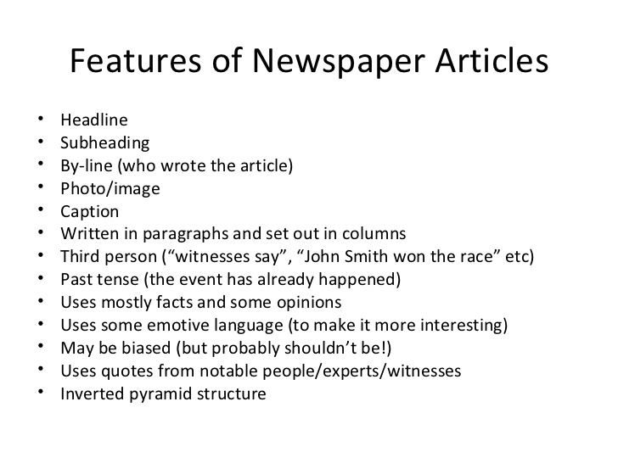

Marking Key: Yr 9: “A Soldier’s Story” Historical Inquiry (Notes)

|  |  |  |  |  |  |
| --- | --- | --- | --- | --- | --- |
|  | 1 | 2 | 3 | 4 | 5 |
| ***Part 1 - Notes from the article provided*** |  |  |  |  |  |
| Question 1 addressed |  |  |  |  |  |
| Question 2 addressed |  |  |  |  |  |
| Question 3 addressed |  |  |  |  |  |
| Question 4 addressed |  |  |  |  |  |
| Question 5 addressed |  |  |  |  |  |
| Question 6 addressed |  |  |  |  |  |
| Question 7 addressed |  |  |  |  |  |
| Question 8 addressed |  |  |  |  |  |
| Question 9 addressed |  |  |  |  |  |
| Question 10 addressed |  |  |  |  |  |
| Organisation to create order |  |  |  |  |  |
| ***Part 2 - Notes from your own soldier*** |  |  |  |  |  |
| Question 1 addressed |  |  |  |  |  |
| Question 2 addressed |  |  |  |  |  |
| Question 3 addressed |  |  |  |  |  |
| Question 4 addressed |  |  |  |  |  |
| Question 5 addressed |  |  |  |  |  |
| Question 6 addressed |  |  |  |  |  |
| Question 7 addressed |  |  |  |  |  |
| Question 8 addressed |  |  |  |  |  |
| Question 9 addressed |  |  |  |  |  |
| Question 10 addressed |  |  |  |  |  |
| Organisation to create order |  |  |  |  |  |
| Bibliography |  |  |  |  |  |

Mark /46 Weighting 4%(Notes)

Teacher’s comments: